Title: Vulnerability Scanning

The tool used to identify the network port and vulnerability scanning.
- Nmap
- OpenVAS
- Nikto

Task:
- Nmap
Detect open ports and service versions.

nmap -sV -O 192.168.1.190

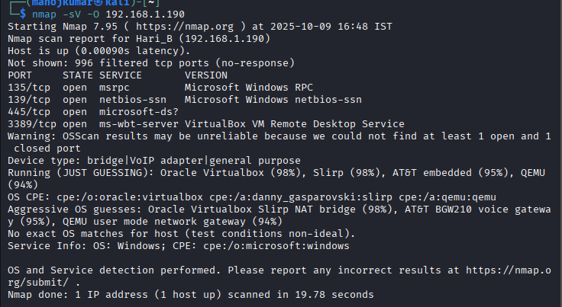

- Nikto
Find web application / service issues.

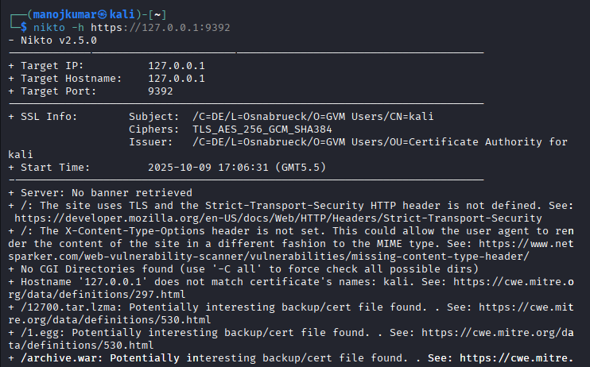
- OpenVAS
- Scan target from web UI (https://127.0.0.1:9392)
- Full vulnerability assessment with CVSS Scores.
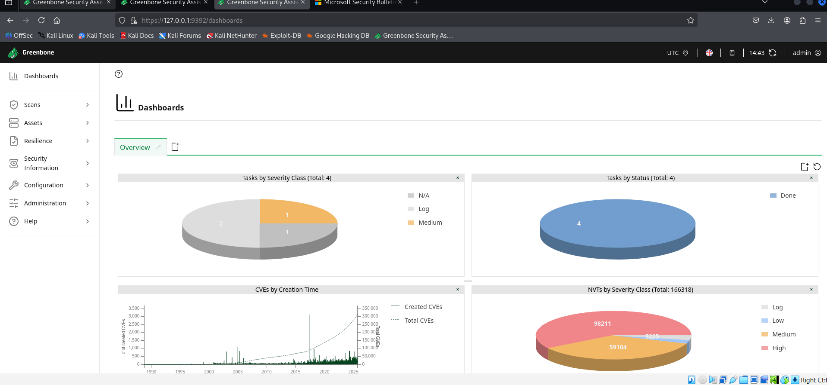

- Analyse and Prioritize Vulnerabilities

Use CVSS Calculator to determine.

Severity | CVSS Range | Action
Critical | 9.0 - 10.0 | Immediate Action Required
High | 7.0 - 8.9 | Fix as soon as possible
Medium | 4.0 - 6.9 | Fix based on business impact
Low | 0.1 - 3.9 | Acceptable Risk Not required the immediate remediation

- Document Result

Record findings in a excel.

Scan ID | Vulnerability Name | CVSS Score | Priority | Host
1 | Adobe Acrobat 9 PDF Document Encryption Weakness Vulnerability - Windows | 7.5 | High | 192.168.1.190
2 | Adobe AIR < 1.5 JavaScript Code Execution Vulnerability | 6.8 | Medium | 192.168.1.190
3 | ASP.NET Core 3.0.x < 3.0.2, 3.1.0 Multiple Vulnerabilities (Jan 2020) | 8.8 | High | 192.168.1.190

Test: Scan a Metasploitable2 VM with Nmap (nmap -sV 192.168.1.100) and OpenVAS.

Nmap
Quick full surface scan.

nmap -p- -T4 -sV -sC --script vuln -oA nmap_full 10.0.2.15

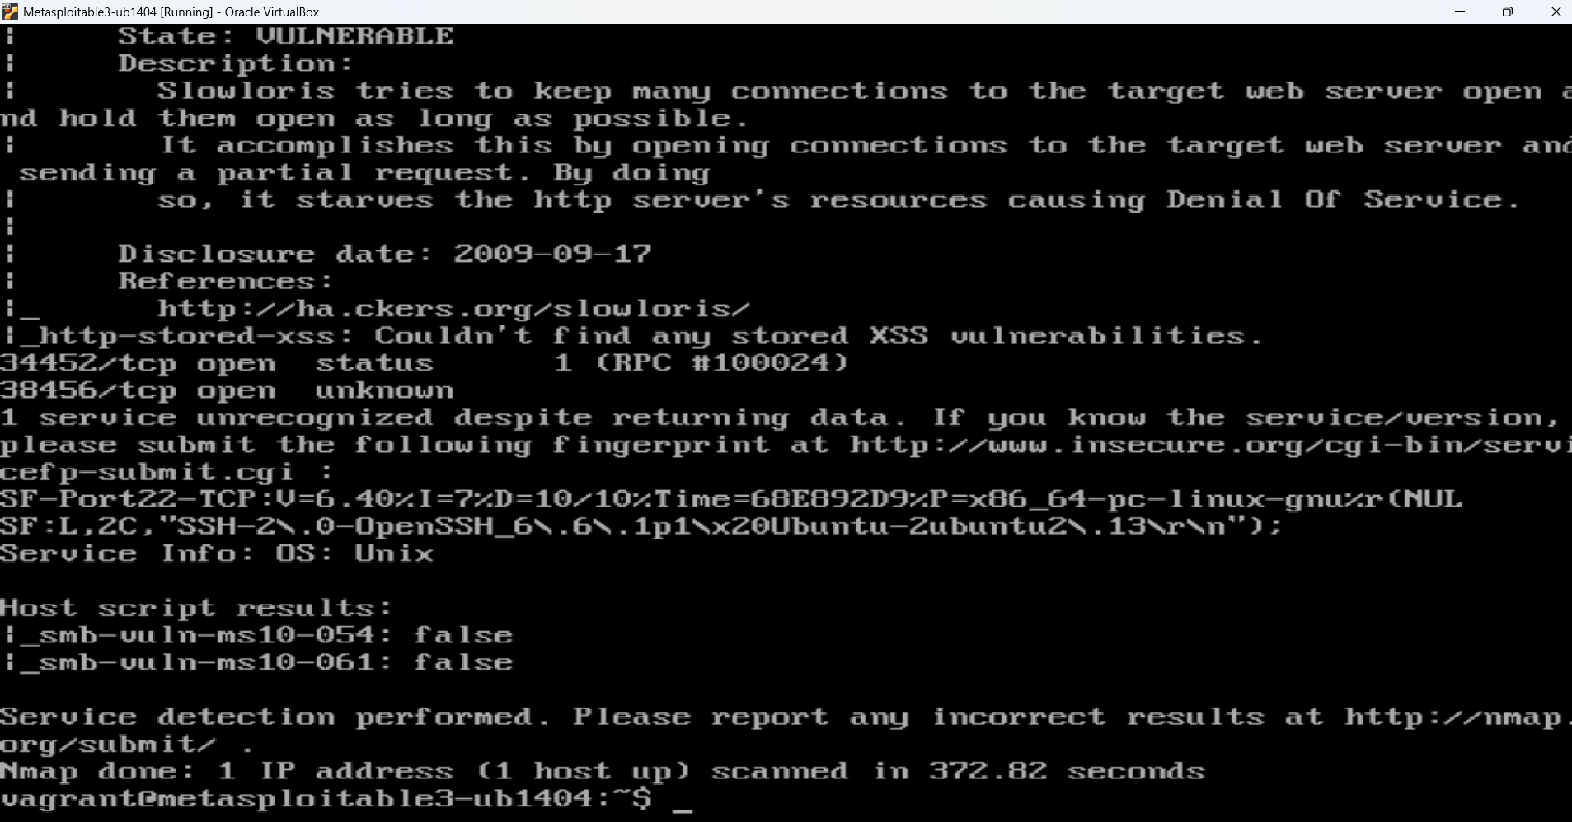

OpenVAS
- Open browser to https://127.0.0.1:9392
- Login with your GVM Credential

- Create target and scan

- Create a target set host (10.0.2.15)
- Create task select the target and a relevant scan config (like full and fast / full and deep)
- Run task
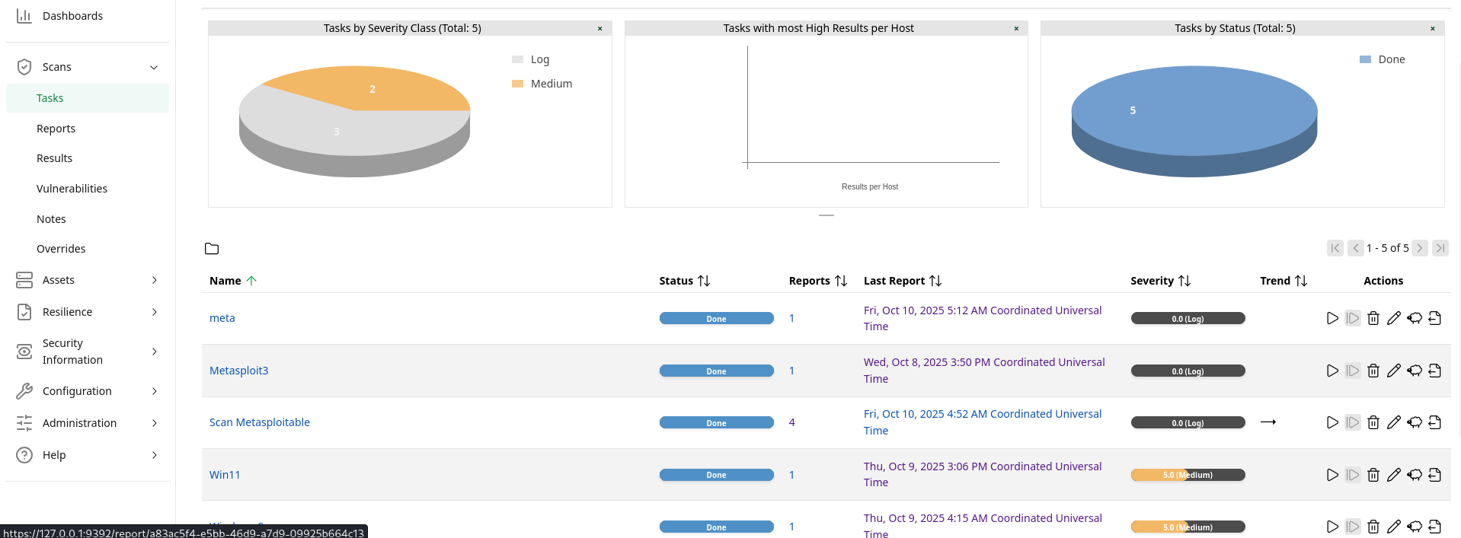
- Export Report
- After completion, export and XML, CSV, and PDF.
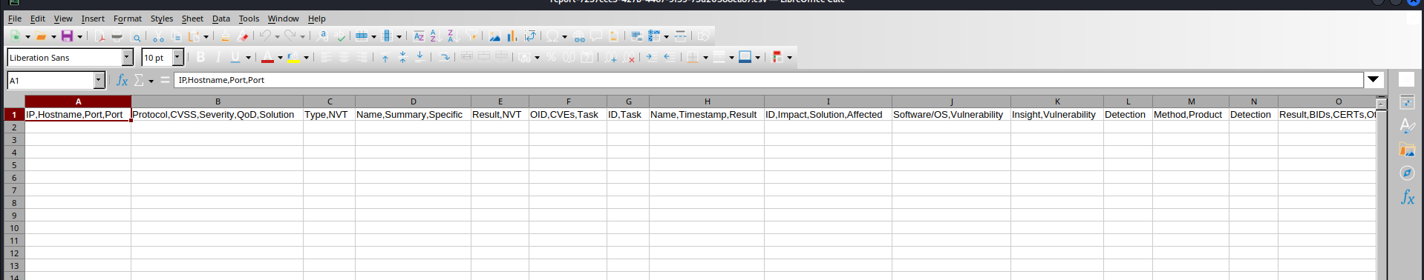

Done — the document now focuses on your titled case “Critical Web Vulnerabilities”, with there is no findings for CVE on 10.0.2.15 detailed technical info, and remediation steps.

Title: Reconnaissance Practice

Maltego

- Visualize and correlate information.
- Install maltego in kali

sudo apt install maltego

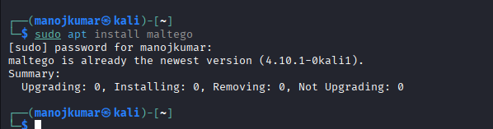

- Then open maltego through terminal

maltego

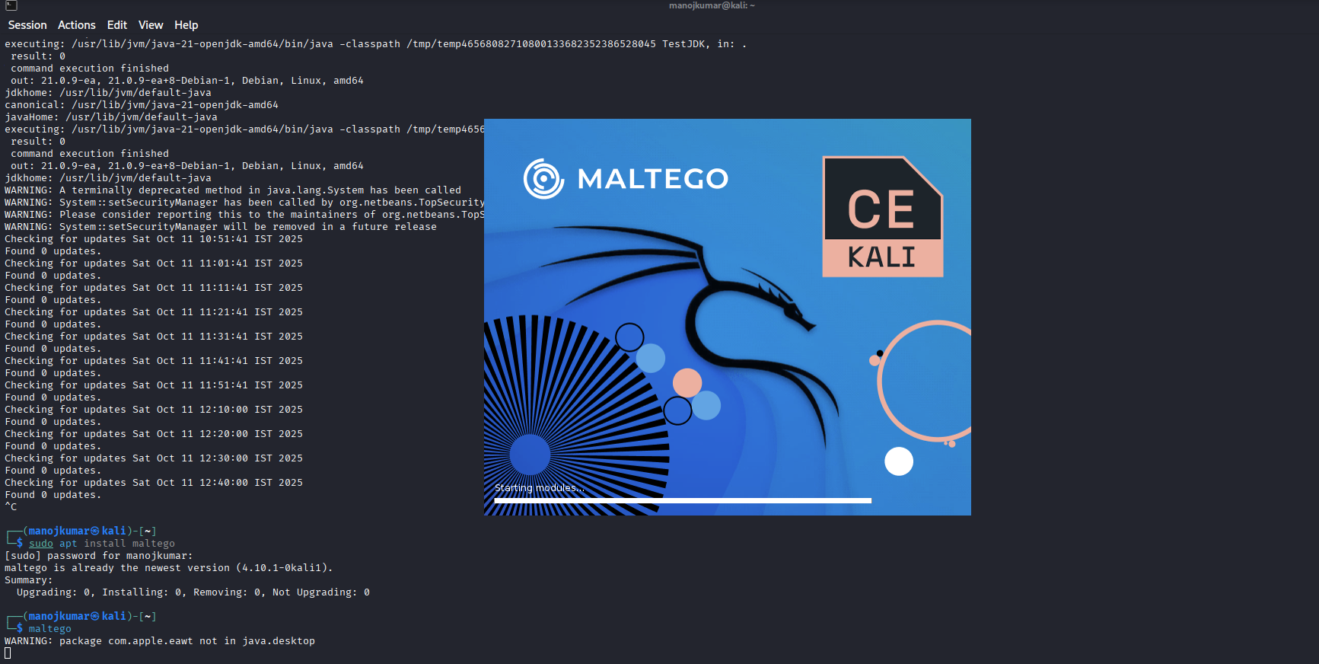
Step:

- Open Maltego Choose a transform set
- Start with Domain (swiss)
- Run transforms
- DNS Name (swiss.com)
- MX Record (webmail.swiss.com)
- To WHOIS information (swiss export, Michael Reber)
- Analyze relationship and visualize results.

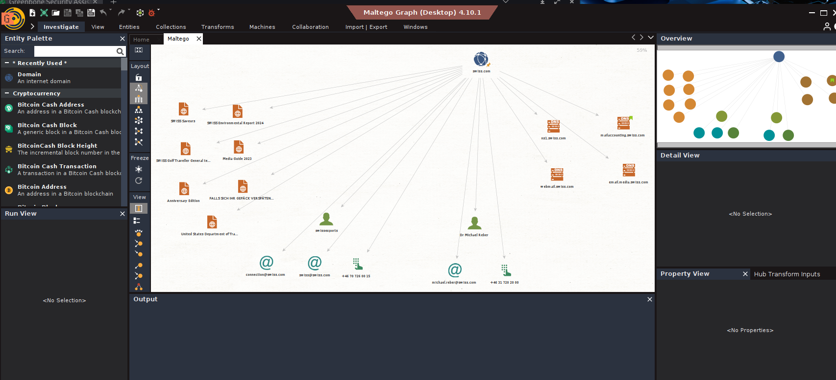

- Export the graph PNG or PDF.

Title: Exploitation Lab

Burp Suite

- Burpsuite is installed on kali linux by default
- However, if for whatever reason you don’t have burp installed.

sudo apt-get update
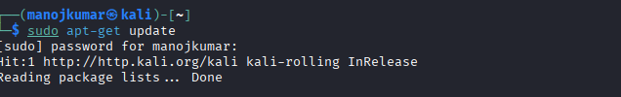

sudo apt-get upgrade
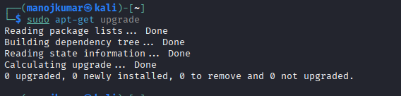

- Then install burpsuite

sudo apt install burpsuite

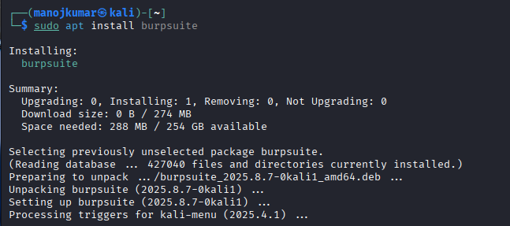

- Open terminal and run burpsuite.

burpsuite

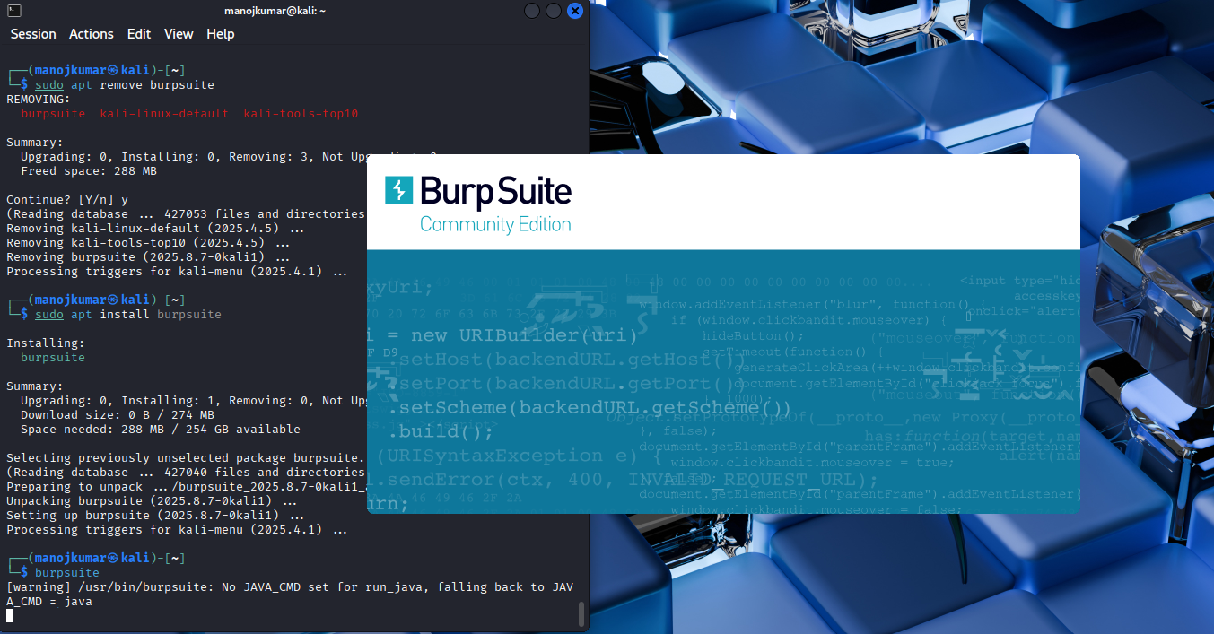

- Live passive crawl from proxy all traffic
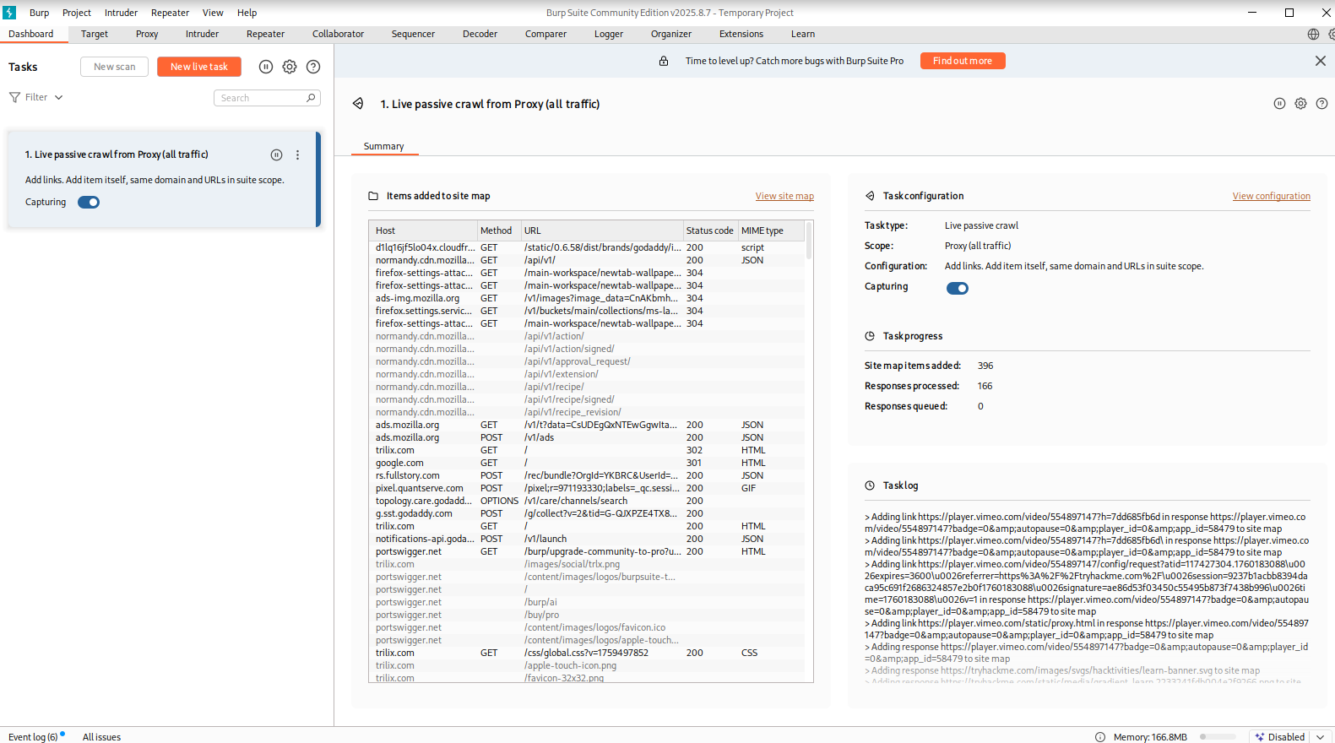

- Target Scope use these setting to define exactly what hosts and URLs constitute the target for your current network.

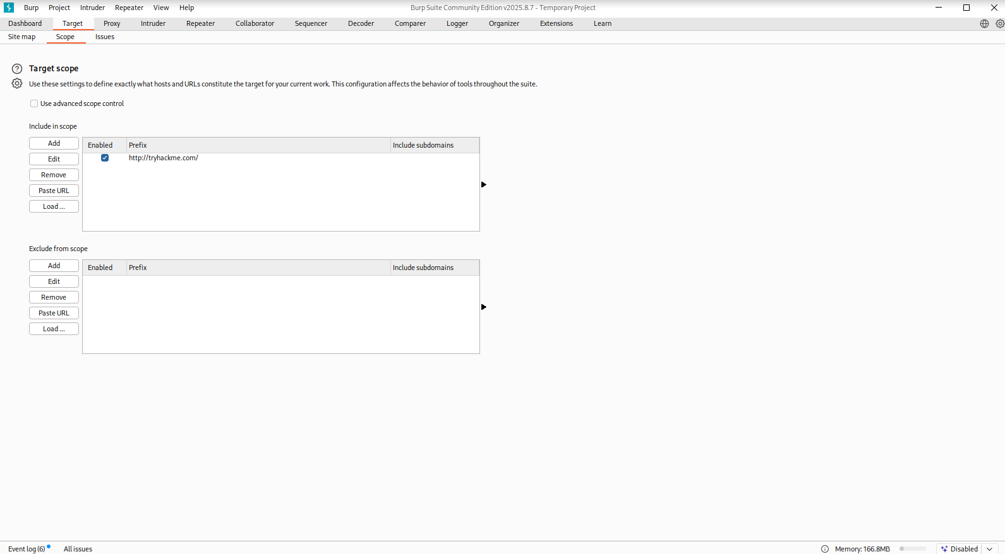

Proxy route browser traffic through burp to capture full request and response. Use scope rules to avoid crawling out of target scope and save http history and tag interesting items.

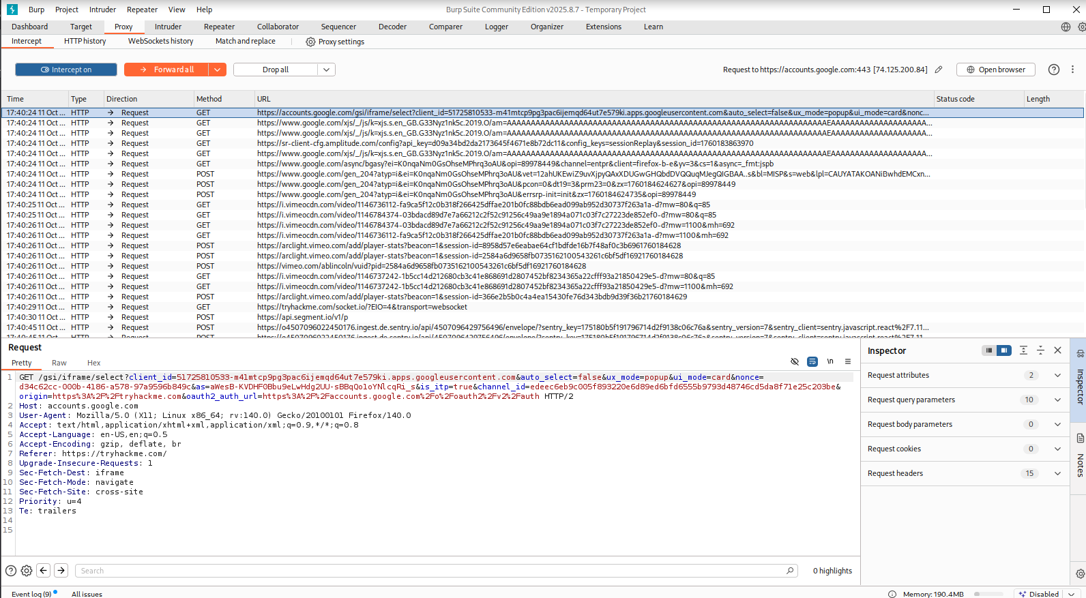

Title: Post-Exploitation Practice

Volatility

Volstility 3 actively developed, python 3, modern plugins and output formats.

- Install volatility3 from pypi

pip install –upgrade pip

pip install volatility3

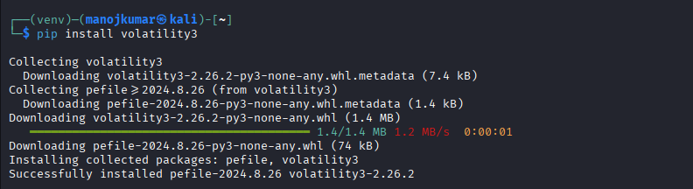
- Verify the volatility3 installation
vol -h

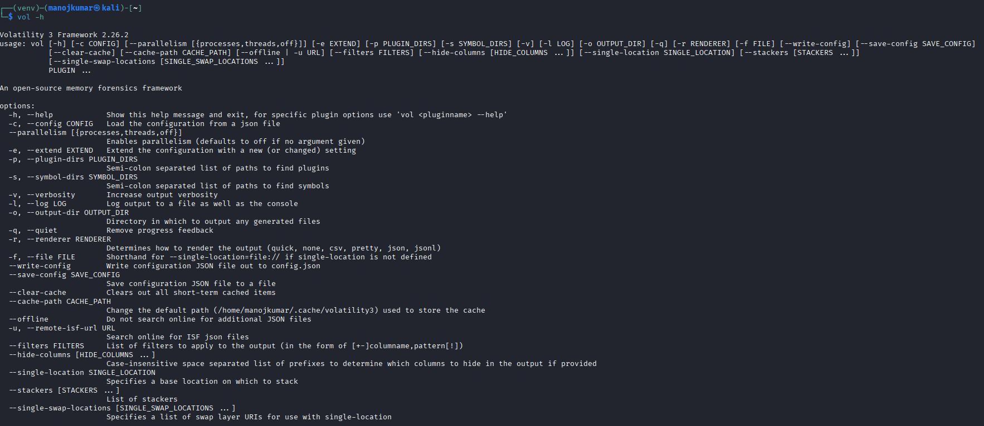

Volatility 3 Workflow

- Confirm image type, architecture, suggested plugins

vol -f memory.img windows.info

- List processes

vol -f memory.img windows.pslist

- Find hidden

vol -f memory.img windows.psscan

- Show command line

vol -f memory.img windows.cmdline
vol -f memory.img windows.consoles

Title: Capstone Project: Full VAPT Cycle

Only run these steps on machines you own or explicitly have authorization to test.

- Find the target IP in kali

ip a
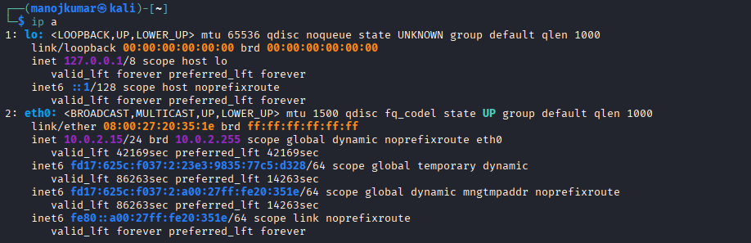

- Ping range to find live hosts

for ip in 10.0.2.15; do ping -c1 -W1 $ip &>/dev/null && echo "live: $ip"; done

- Fast port and service scan using nmap

nmap -sC -sV -p- -T4 -oA scans/initial 10.0.2.15

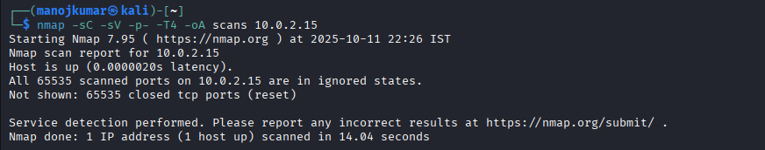

- Focused scan

nmap -sS -sV --script vuln -T4 -oN vuln_scan 10.0.2.15

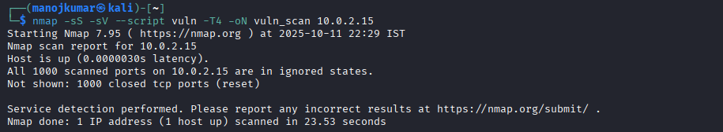

- Enumeration pre-service use the result of the nmap scan to enumerate services

HTTP/Web

gobuster dir -u http://10.0.2.15/ -w /usr/share/wordlists/dirbuster/directory-list-2.3-medium.txt -o gobuster_http.txt -t 50
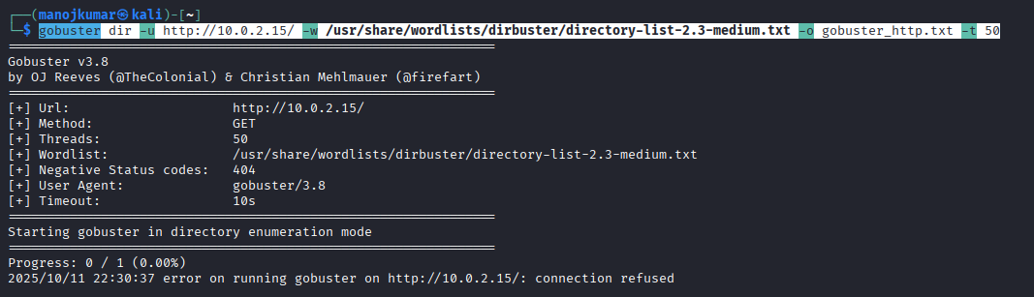

Nikto scan

nikto -h http://10.0.2.15 -o nikto_http.txt

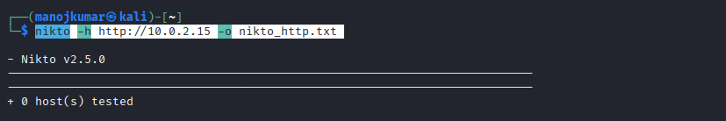

FTP
- Anonymous login check

ftp 10.0.2.15
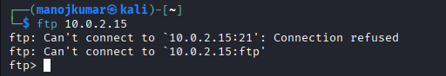

SNMP
- SNMP is Check public community

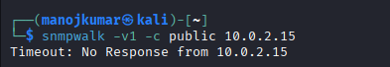

Vulnerability discovery

- Map observed versions to known CVEs locally

nmap --script vuln

